Title : Import the legacy data from different sources such as ( Excel , Sql Server, Oracle etc.) and load in the target system. ( You can download sample database such as Adventure works, Northwind, foodmart etc.).
Name : - Mehatab Mahibub Sanadi
Roll No. : - CO4050
Class : - BE Computer
Subject : - Business Intelligence
*********************************************************************
PART 1: Create Data Warehouse
Step 1: Open SSMS
Open SQL Server Management Studio
Connect:
Server: .
Authentication: Windows Authentication
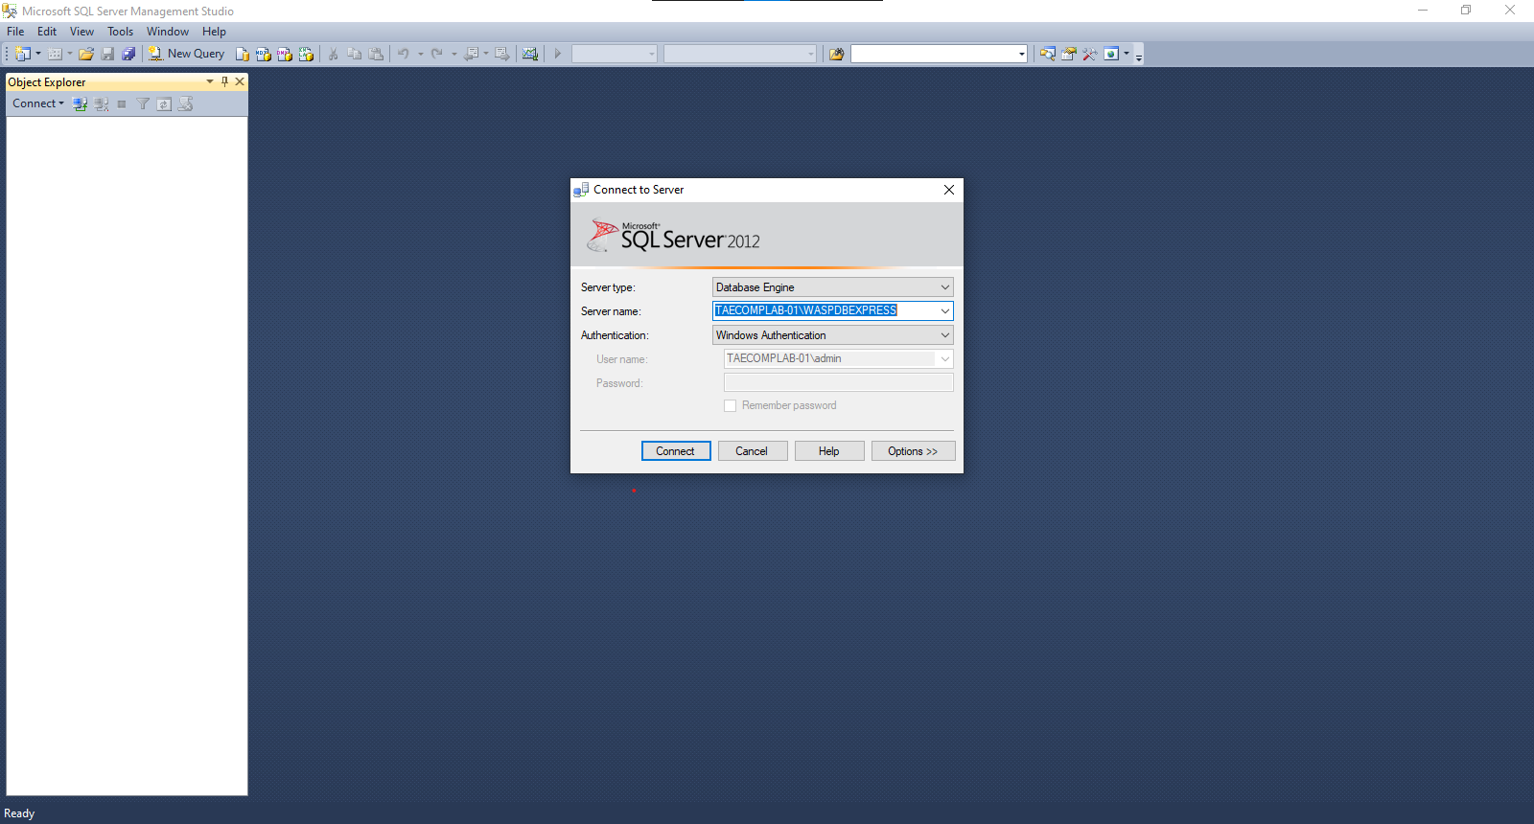
Step 2: Create Database
CREATE DATABASE Sales_DW;
GO

USE Sales_DW;
GO
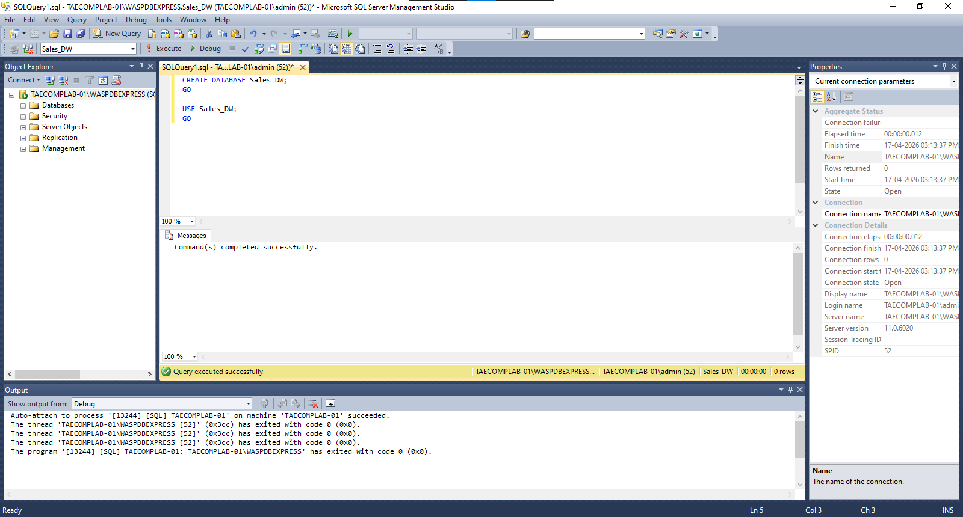
Step 3: Create Tables
Dimension Tables
CREATE TABLE DimProduct (
ProductID INT PRIMARY KEY,
ProductName VARCHAR(100),
Category VARCHAR(50)
);

CREATE TABLE DimDate (
DateID INT PRIMARY KEY,
Year INT,
Quarter VARCHAR(10),
Month VARCHAR(20)
);
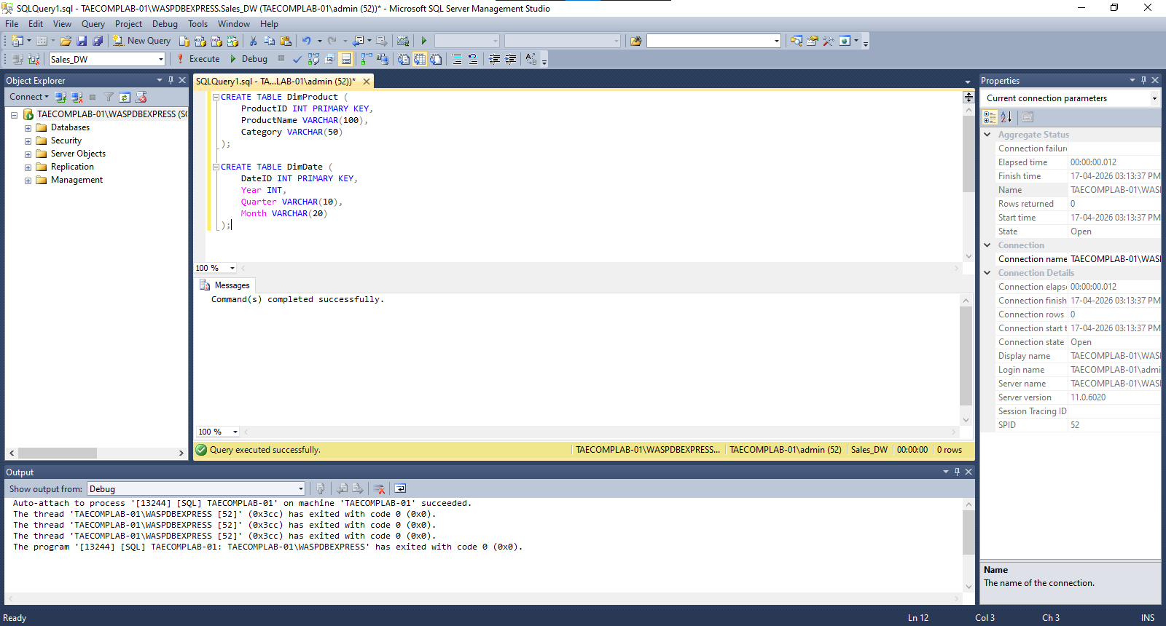
Fact Table
CREATE TABLE FactProductSales (
SalesID INT PRIMARY KEY,
ProductID INT,
DateID INT,
SalesAmount INT
);
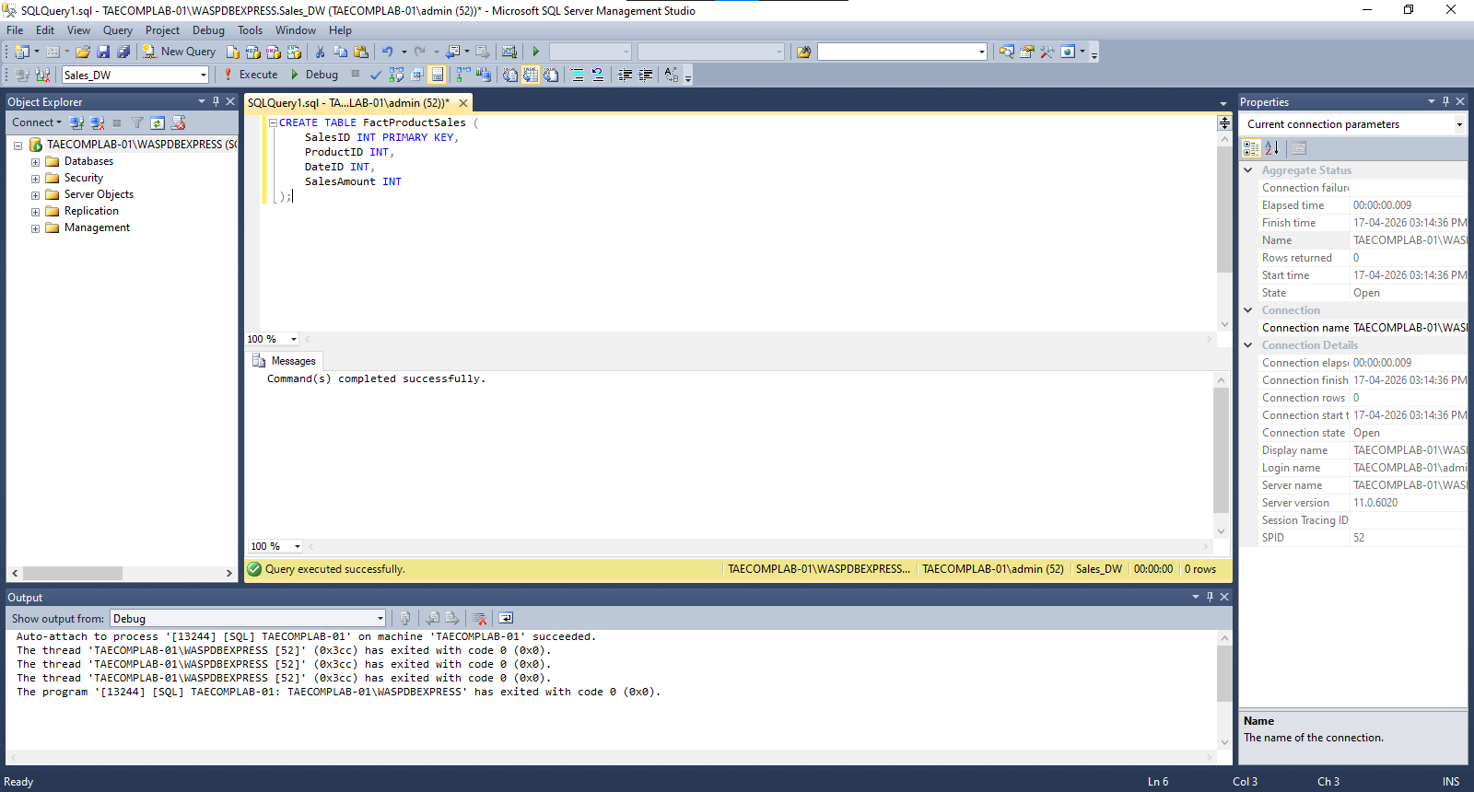
Step 4: Insert Sample Data
INSERT INTO DimProduct VALUES
(1, 'Laptop', 'Electronics'),
(2, 'Mobile', 'Electronics');

INSERT INTO DimDate VALUES
(1, 2024, 'Q1', 'Jan'),
(2, 2024, 'Q1', 'Feb');

INSERT INTO FactProductSales VALUES
(1, 1, 1, 50000),
(2, 2, 2, 30000);
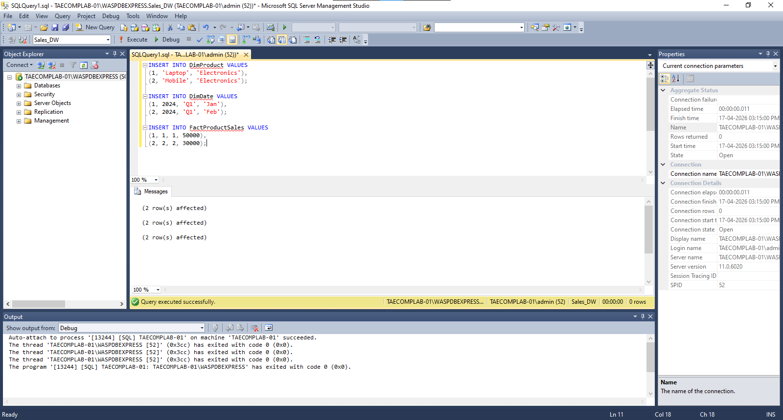
Step 2: Create New Data Source (SSDT)
1. Open Visual Studio (SSDT).
2. Go to: File → New → Project
3. Select: Analysis Services Multidimensional Project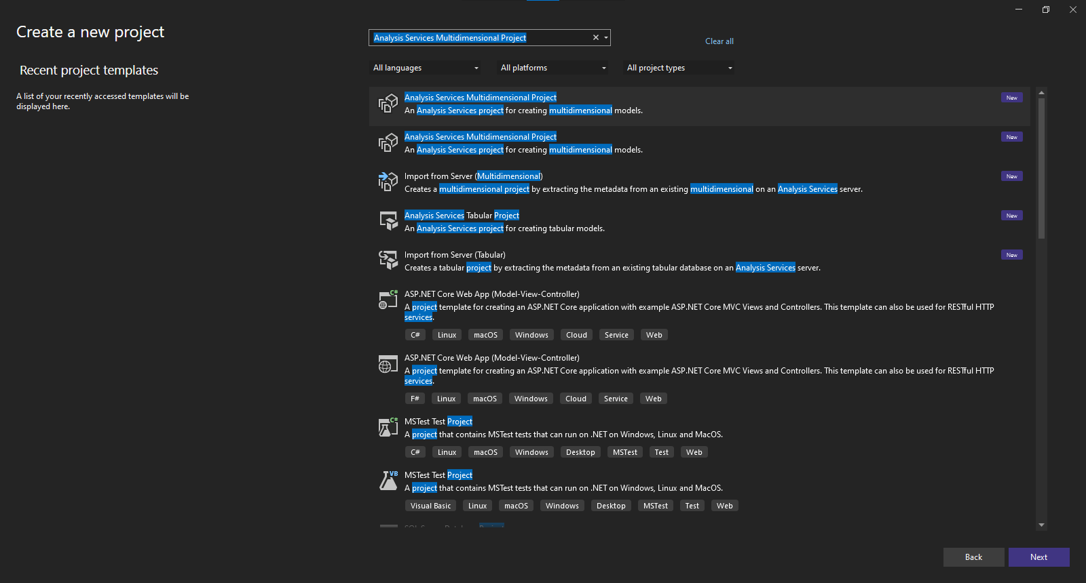
4. Click OK.
5. In Solution Explorer:
Right-click Data Sources → New Data Source
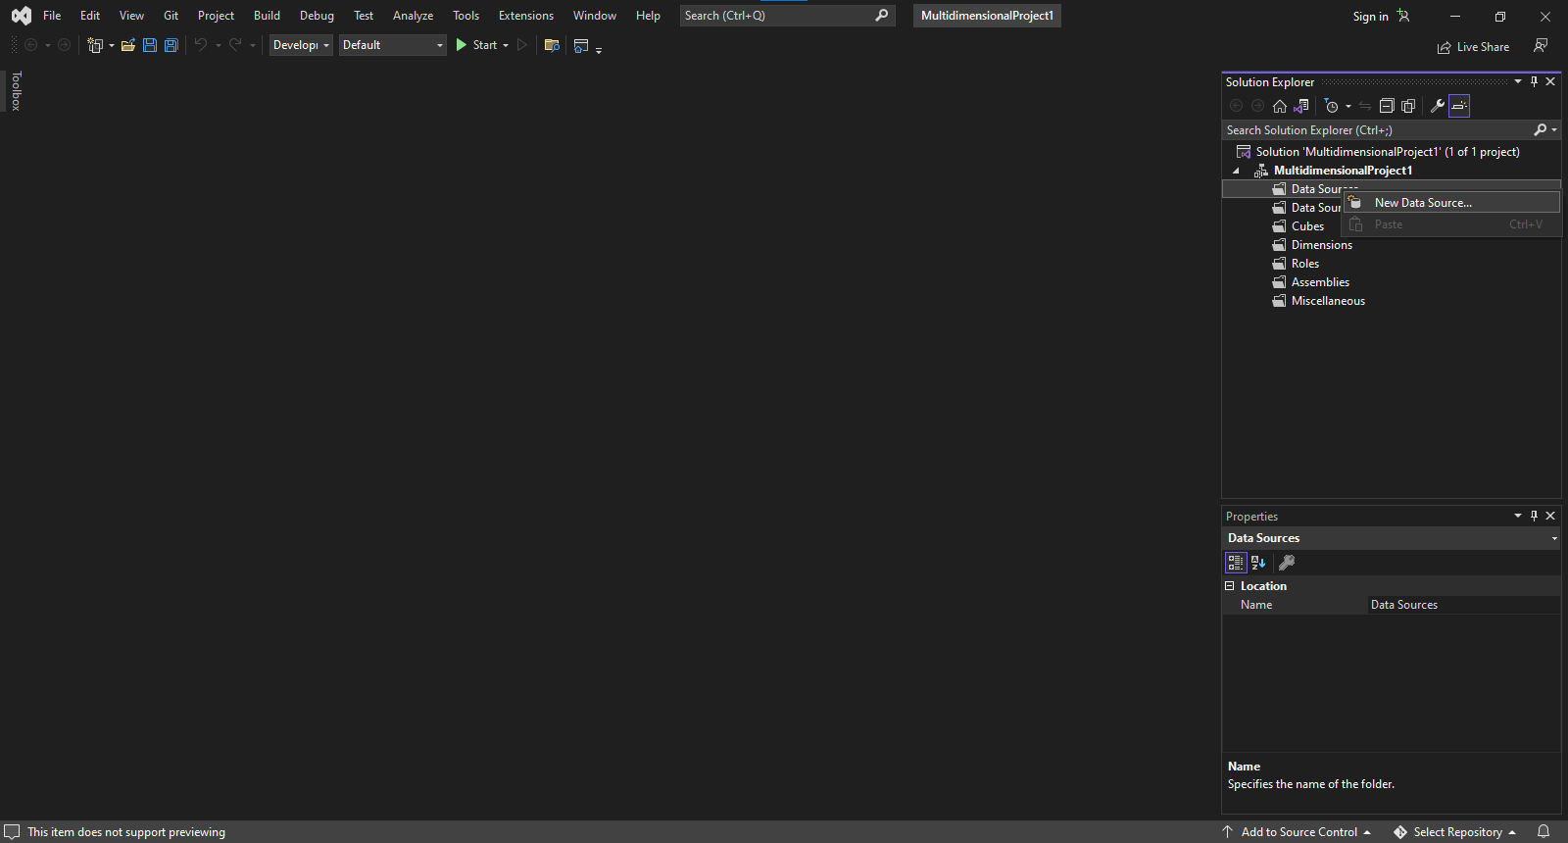
6. Click New.
7. Enter:
Server Name: `.`
Database: `Sales_DW`
8. Select Windows Authentication.
9. Click Next → Finish.
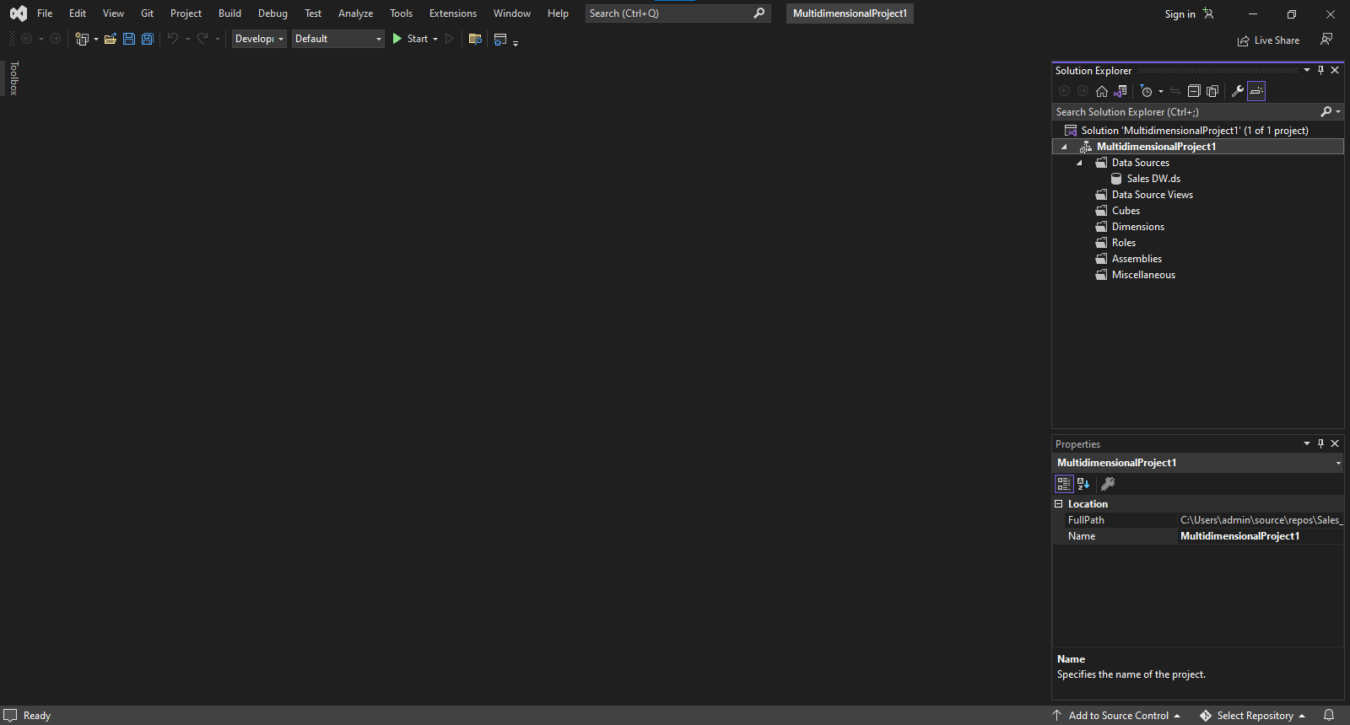
Step 3: Create Data Source View
1. Right-click Data Source Views → New Data Source View
2. Click Next
3. Select the created Data Source
4. Select tables:
- FactProductSales
- DimProduct
- DimDate
5. Click Finish
Step 4: Create Cube
1. Right-click Cubes → New Cube
2. Select:
Use existing tables
3. Select Fact Table:
`FactProductSales`
4. Select Measures:
`SalesAmount`
5. Select Dimensions:
- DimProduct
- DimDate
6. Click Finish
Step 5: Dimension Modification
1. Double-click DimProduct
2. Add attributes:
- ProductName
- Category
Step 6: Create Hierarchy in Date Dimension
1. Double-click DimDate
2. Add attributes:
- Year
- Quarter
- Month
3. Create hierarchy:
* Year → Quarter → Month
Step 7: Deploy and Process Cube
1. Right-click Project → Properties
2. Set Server Name:
localhost
3. Click Apply → OK
4. Right-click Project → Deploy
5. Wait for Deployment Successful
6. Right-click Cube → Process
7. Click Run

Conclusion : In this way we successfully implement cube with suitable dimension and fact tables based on ROLAP, MOLAP and HOLAP model

